Ithaca College 2024 Biketober Event

Throughout the month of October, Ithaca College promoted a free and fun way for students, staff, and faculty to get outside, ride their bikes and even win prizes. This year, [**Go Ithaca**](https://www.goithaca.org/), a local transportation benefits organization, and [**Love to Ride**](https://www.lovetoride.net/ithaca), a transportation management platform, collaborated to track mileage, encourage ridership and also give away two $500 cash prizes to active participants. Winners were randomly chosen based on the points they accumulated - the more points participants earned, the more chances they had to win.

Ithaca College participants really set the bar high in the Biketober challenge, logging a total of

2,736 miles throughout October. Of those miles,1,248 were “transport miles”, meaning participants opted for biking instead of the use of a car! For comparison, Cornell University participants recorded just 994 total miles over the same time period. Ithaca College earned the #1 spot for local workplaces with 500-1,999 staff members and ranked #18 worldwide among workplaces with over 500 employees!

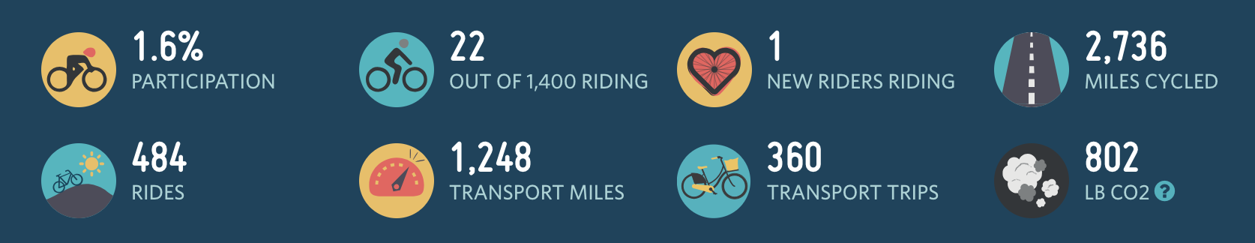

Ithaca College’s Biketober Results.

Biking isn’t just a fantastic way to enhance your health and save on travel costs - it’s also a significant way to reduce greenhouse gas emissions and help protect the planet. Throughout the month of October alone, IC’s Biketober participants prevented the release of 802 pounds of CO2 by choosing to bike instead of drive. Imagine what this number could be with even more participants year-round!

A big congratulations to this year's winners, Katarzyna Bartoszynska and Marilyn Dispensa! Katarzyna Bartoszynska shared that she had recently gotten a new bike, making the Biketober challenge “the perfect motivation to ride as much as she could.” She added that the challenge “brought her a lot of joy.”

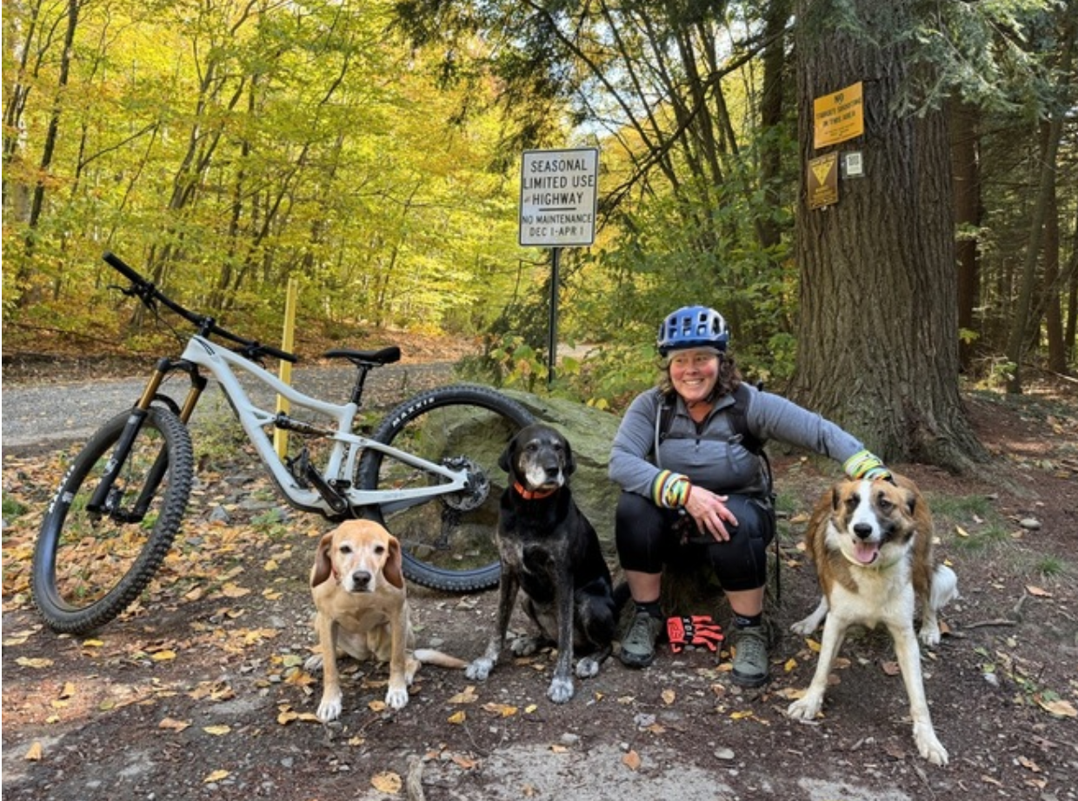

Biketober winner Marilyn Dispensa after a Fall ride with her dogs.

Thank you to everyone who participated in Biketober and to **Go Ithaca** and **Love to Ride** for facilitating this competition. We hope you had a great time and we are already looking forward to next year’s Biketober event - see you around campus and the community on your bike!